I hereby give notice that Councillors are summoned to attend a meeting of Hurstbourne Tarrant Parish Council on Monday 21st March 2016 at 7.30 pm in the Community Hall.
Members of the Press and Public are entitled and encouraged to attend.

AGENDA
- Apologies - To receive any apologies for absence from councillors
- Public participation – To receive any questions or petitions (for information only)
- Speaker Steve Bull – applicants’ representative on planning application 16/00504/FULLN Old Plough Church St.
- Actions arising from previous minutes (for information only):
Cllr Jamie Williams offered to investigate a bid under the Leader Fund that might provide some matched funding for new SLR equipment. JW to action.
The Test Valley Resilience Forum on Saturday 27th February, 9.30 am at Longstock Village Hall. Cllr Mark Thomas agreed to attend and Cllrs DS & JW were asked to provide brief on the parish emergency plan. MT, DS & JW to Action
Planning actions: 16/00013/FULLN - Comment to be submitted regarding car parking arrangements. JW
HP786475 Land Registry - JW to pass details onto the landowner
16/00326/FULLN - JW to summarise planning application and e-mail councillors with the details, councillors will then make their decision
16/00332/FULLN - JW to summarise planning application and e-mail councillors with the details, councillors will then make their decision.
The new community hall sign posts were waiting to be installed. Councillors agreed they would fund the installation cost. Cllr DS agreed to commission the work. DS to action.
Councillors agreed that the vacancy should be advertised on the village website. DB to action.

- Minutes of meeting 15th February 2016- To approve and sign the minutes as a true record of the parish council meeting held on 15th February 2016.
- Declarations of interest - To receive any declarations of interest from councillors
- The co-option of a new parish councillor – the parish council has a vacancy for a new parish councillor. TVBC has authorised that the vacancy may be filled by co-option.
- CSW report– Progress report - Speaker Rupert Conder
- Hurstbourne Tarrant Community Centre (HTCC) quarterly report – Speaker Susie Hoare
- Correspondence - To review the correspondence received since the last meeting and to agree any actions as necessary.
- PCC donation request towards St Peter’s churchyard maintenance.
- Queen's 90th Celebrations - 10-12th June?
- Feedback from the Resilience Forum on Community Emergency Planning – Cllr Mark Thomas
- Feedback from the HIOW Devolution Forum – parish clerk.
- Planning Applications. – To review details of planning applications received and to agree what actions should be taken.
- Councillors’ Reports - To receive councillors’ monthly reports and to agree what actions should be taken.
- Clerk’s Report – To receive the clerk’s monthly report and to agree what actions should be taken.
- Agenda Planning - Annual Parish meeting & Annual Parish Council meeting 18th May 2015.
- Next meeting 18th April 2016 and to receive any forward plan updates or agenda items
- Performance Monitoring 15/16 YE – financial year end report & Annual Return
- Finalise agendas for the Annual Parish and the Annual Parish Council meetings.
- Disbursements – To review and authorise monthly payments.

MINUTES OF MEETING | : 15th FEBRUARY 2016
TIME OF MEETING | : 7.30 p m
venue of meeting | : COMMUNITY HALL
Type of meeting | : ORDINARY
present | : MR MARK THOMAS (MT)
 | : MR JAMIE WILLIAMS (JW)
 | : MR MARK BETTERIDGE (MB)
 | : MRS LOUISA RUSSELL (LR)
Chaired by | : MR DAVID SULLIVAN (DS)
in attendance | : Mr DAVID Baker (DB)
Also present | : Cllr TIM ROLT (HCC)  : 5 parishioners

134. Apologies
134.1 Apologies were received from Rupert Conder.

135. Public Participation
135.1 None.

136 Actions arising
136.1
Cllr Jamie Williams offered to investigate a bid under the Leader Fund that might provide some matched funding for new SLR equipment. JW to action. Carried forward
HOIW Devolution meeting planned for 1st March was discussed. Councillor Mark Thomas confirmed he was unable to attend. Others councillors were asked to see if they could represent the parish council. Clerk will attend.
The Environment agency were now issuing groundwater reports on a monthly basis. These reports would be published on the parish website. DB to action. Completed
The clerk asked for approval to advertise the casual vacancy that had occurred on the council. Statutory notices would be published as soon as possible and TVBC would be notified. DB to action. Completed

137. Minutes of meeting 18th January 2016
137.1 The minutes of the Parish Council meeting of 18th January 2016 were approved and signed by the Chairman.

138. Declarations of interest
138.1 Councillor Jamie Williams declared a personal interest in planning application 16/00326/FULLN and agreed he would not take part in any vote or decision on the matter.
138.2 Councillor Mark Betteridge declared a personal interest in planning application 16/00332/FULLN and agreed he would not take part in any vote or decision on the matter.

139. Community Speed Watch (CSW) report
139.1 Rupert Conder sent his apologies and confirmed there had been no speed watch activity since the January PC meeting.

140. Correspondence
140.1 The list of correspondence received during the month was read and passed to the relevant councillor.
- Gary Edward’s report on the Bourne Valley Flood 05/02/16 meeting with HCC Highways and HCC Engineering was discussed by councillors.
- Received a copy of the adopted version of the TVBC Revised Local Plan 2011 – 2029 which was passed to Cllr Jamie Williams for safe keeping.
- The Test Valley Resilience Forum on Saturday 27th February, 9.30 am at Longstock Village Hall. Cllr Mark Thomas agreed to attend and Cllrs DS & JW were asked to provide brief on the parish emergency plan. MT, DS & JW to Action.

141. Planning Applications

141.1
RESOLVED: Councillors agreed that the actions documented below would be taken:

16/00013/FULLN | 21 Jan 16 | Change of use to residential to include internal alterations to form living space, replace flat roofs with pitched roofs and new brick gables. Village hall, Ibthorpe Road, Hurstbourne Tarrant, Andover. Mr Steven Smith. Comment to be submitted regarding car parking arrangements. JW to Action.
12/00126/FULLN | 21 Jan 16 | Erection of garden shed. Edrup Cottage, Ibthorpe, Andover, Hampshire. Mr and Mrs David Harrison. No comment
15/03168/FULLN | 29 Jan 16 | Single storey rear extension on site of existing utility/kitchen to provide kitchen and family room, demolition of existing garage, erection of detached three bay garage/log store/home office with storage over and construction of vehicular access. Willow Cottage, Ibthorpe Road, Hurstbourne Tarrant, Hampshire. Mr and Mrs William Maclachlan. No comment
HP786475  Land Registry | 05 Feb 16 | Notice to an adjoining owner of an application for registration of a person in adverse possession: Land adjoining 12 The Crescent Hurstbourne Tarrant Andover SP110AP. Mr & Mrs Brian Purver. JW to pass details onto the landowner.
16/00326/FULLN | 11 Feb 16 | Change of use of land from agricultural to residential and erection of detached double garage with gravel driveway/area for parking and turning. Tree Tops, Lockes Drove, Pill Heath, Andover. Mr and Mrs J Bass. JW to summarise planning application and e-mail councillors with the details, councillors will then make their decision.
16/00332/FULLN | 12 Feb 16 | Extension and partial conversion of garage to include utility room and home office, front storage units and rear canopy to patio area of house. The Squirrels, The Dene, Hurstbourne Tarrant, Andover. Mr and Mrs Jeff Smith. JW to summarise planning application and e-mail councillors with the details, councillors will then make their decision.

142. Councillors’ reports:
142.1 Councillors, Jamie Williams had nothing further to report.
142.2 Councillor Mark Thomas presented his monthly report. (see appendix A for full details)
- Parish Working Party on 6th February was a great success - Just under thirty people turned out on a wet and blustery day, meeting in three locations in the village to carry out tidying and light maintenance. It was agreed that Saturday 7th May 9.00am would be the date for the next parish working party to be held.
- Progress report on the installation of a community defibrillator
- Gained approval for the purchase of two new goal nets on King George V playing fields
142.3 Councillor Louisa Russell asked if appropriate warning signs could be considered at the entrances to Horseshoe Lane showing children and pedestrians use the road.
142.4 Councillor Mark Betteridge confirmed that there had been no CSW activity to report. The new community hall sign posts were waiting to be installed. Councillors agreed they would fund the installation cost. Cllr DS agreed to commission the work. DS to action.
142.5 Councillor David Sullivan reported that he had the top soil ready for delivery to the repair of the second goal mouth – work would take place later in the Spring once the first goal mouth was ready to be brought into use.

143. Clerk’s report
143.1 The clerk reported that TVBC had confirmed that the parish council could fill its current vacancy for a parish councillor by co-option. The clerk had issued public vacancy notices requesting nominations to be submitted in writing by the 1st March. Councillors agreed that the vacancy should be advertised on the village website. DB to action.
143.2 2016 invoices for allotments had been issued.

144 HCC/TVBC requests for service

144.1 The clerk presented a list of 7 requests for service that were outstanding against HCC and TVBC. The requests were discussed with Cllr Tim Rolt (HCC) who provided updates on the requests and agreed to monitor their progress through to completion. TR to action.
144.2 A new request was added to the list to have the trees on the A343 through Doles Wood and Bourne Park area cut back as they were encroaching on the carriageway.
144.3 Note: Councillor Peter Giddings (TVBC) did not attend the meeting.

145 Next meeting and forward plan update
145.1 The next ordinary Hurstbourne Tarrant Parish Council meeting will be held on Monday 21st March 2016 in the Community Hall at 7.30 p.m.
Forward plan agenda items:
- To fill a vacancy on the parish council by co-option
- Annual Parish meeting – initial agenda planning
- Annual Parish Council meeting – initial agenda planning

146. Disbursements – 15th February 2016.
146.1 The following cheques were presented for signature:
Number Payee Expenditure Amount
1176 D R Baker Salary Feb £ 131.38
1177 HM Revenue & Customs PAYE £ 87.60
1178 TVBC Annual grounds maintenance £ 678.88

Total authorised £ 897.86

Meeting closed at 8.40 p.m.

Signed……………………………………………………… Date:………………
Chairman

Appendix A
Footpaths & Environment Report
February 2016

Hurstbourne Volunteers - Parish Working Party 6th February 2016
Just under thirty people turned out on a wet and blustery day, meeting in three locations in the village to carry out tidying and light maintenance.
At Ibthorpe, the volunteers tackled the drainage by the bridge at Windmill Lane, removing approximately 18 tonnes of silt. Five bags of litter were collected, signs were washed and extra channels dug to take surface water away from the road into the Swift in Ibthorpe.
At the northern end of the village the group collected about ten bags of litter and assorted rubbish. Verges were strimmed, the footpath to the East of The Rank cut back and steps have been made from the North “bridge” on The Green to the pavement near Londis. Drains were cleared and a number of trees on The Green pruned.
The Church Street group collected four sacks of rubbish from the B3048 and A343. The area around the Community Centre was swept and tidied and turf laid under the goal post. The wire netting on the footbridge was removed as it had become damaged and replaced with anti-slip strips and the growth under the tree seat in the children’s playing area was trimmed.
Thank you to everyone who took part and to TVBC for the loan of litter pickers, high viz vests and rubbish sacks, also for so promptly collecting the filled bags from three locations.
Date to be confirmed for the next working party in May?

Community Defibrillator
Following helpful feedback from Steve Swift and with agreement of Patrick Vaughan-Fowler, it was agreed that the defibrillator should be sited at The George & Dragon. Patrick is consulting with the planning department. Current funding period has closed with BHF, but we have registered interest in the next round. Two residents have volunteered to be trained in due course – Deirdre Nicol and Dave Ellis.

Goal Post Net
A request has been made to purchase a goal-net for the posts nearest the Community Centre.

Footpaths
Two queries received about the track behind the farm buildings above Lower Farm which has been fenced off. My understanding is this is not a public right of way.

Communications
Hurstbourne Volunteers February Update and advisory sign regarding dogs at lambing time.

MT – 14/02/2016

Mail in: 16th February 2016 to 21st March 2016
Environment
Date | From | Subject
23 Feb 16 | Environment Agency | Groundwater Report 23.02.16
18 Feb 16 | NWD AONB | North Wessex Downs Heritage Forum on Wednesday 23rd March 2016. Book by 11th March

Test Valley Borough Council (TVBC)
Date | From | Subject
16 Feb 16 | Planning | Latest quarterly report from the planning enforcement team
25 Feb 16 | TVAPTC | Governance presentation

Hampshire County Council (HCC)
Date | From | Subject
29 Feb 16 | HCC | Parish Council newsletter

Hampshire Association of Local Councils (HALC)
Date | From | Subject
04.Mar 16 | HALC | E update bulletin
03 Jan 16 | HALC | Annual Conference 2016 - Planning for Tomorrow - 9th March 2016

Central Government Departments
08 Mar 16 | SAAA | Communication letter No 3 – opt out deadline 31st March 2016

Test Valley Borough Council – Planning Services
Reference | Date Received | Subject | Consultation Deadline
 | 17 Feb 16 | Weekly planning list for 12th Feb 16
 | 24 Feb 16 | Weekly planning list for 19th Feb 16
 | 02 Mar 16 | Weekly planning list for 26th Feb 16
 | 09 Mar 16 | Weekly planning list for 04th Mar 16
 | 24 Feb 16 | NHS Application for outline consent and premises approval at Charlton Hill Surgery, Charlton Road, Andover, SP103JY Dr Ford & Partners | 08 Apr 2016
16/00504/FULLN | 04 Mar16 | Demolition of single storey lean-to extension and erection of part single-storey, part two-storey extension; associated alterations to existing building. Old Plough, Church St, Hurstbourne Tarrant, Hampshire Mr & Mrs F Colquhoun | 01 Apr 2016
16/00547/TREEN | 05 Mar 16 | T1 Prunus sp – Remove. The Old House, Ibthorpe, Andover Mr Andrew Barrett | 22 Mar 2016

Emails & other correspondence
Date | From | Subject
24 Feb 16 | P Symes PCC | Donation request towards the upkeep of St Peters churchyard
16 Feb 16 | P Symes PCC | Queen's 90th Celebrations - 10-12th June – Does PC have any plans?
20 Feb 16 | Paul Winby | Safer route to school - proposal
08 Mar 16 | Tangley PC | Invoice for shared SLR service 2016.17
08 Mar 16 | English Rural Housing | Re-sale of 31 Dines Close
09 Mar 16 | Test Valley Police | Rural policing event - Stockbridge Town Hall on the 12th of April between 18:00 and 20:00

Footpaths Report March 2016
- No issues to report
- Goal net installed on football pitch

Community Resilience Workshop – 27th February 2016
Community Emergency Action Plan
In extreme conditions such as heavy snow and flooding, there is a possibility that the emergency services may not be able to reach the scene immediately. In such circumstances, the initial response may rely entirely on local people. To co-ordinate such activity, some councils have formulated a Community Emergency Plan to help their community to prepare for an emergency and reduce its impact. The idea is that local communities may know about particular hazards and problems that affect an area, be aware of individuals who might need assistance in an emergency, and have access to people, resources or buildings that allow them to respond more effectively to specific incidents.
Examples of what a plan might include:
- Nominated points of contact for emergency services and local authority
- Detail of communication channels
- Register of specialist skills in community – eg first aid
- Knowledge of vulnerable residents and requirements
- Arrangements for short term shelter if required
- Initial response guides and trigger points for likely scenarios
Questions for Parish Council:
- Should HBT have a Community Emergency Action Plan ?
- If so, how and in what timeframe ?

M Thomas
March 2016

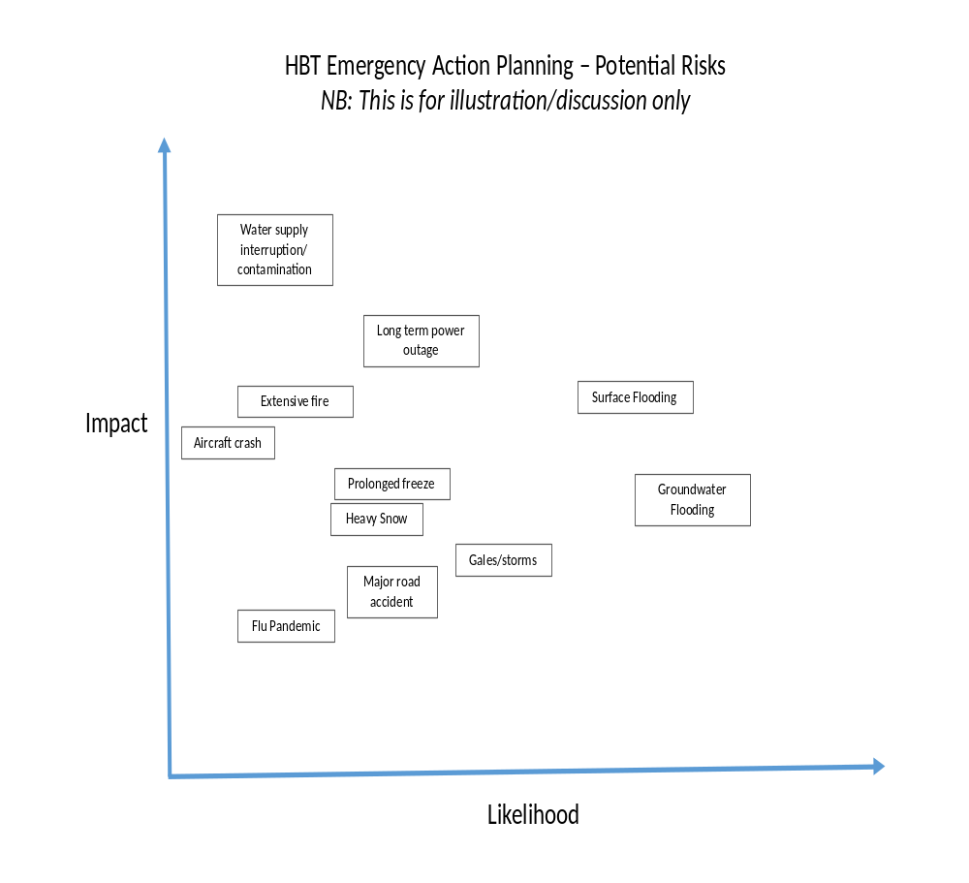

Report

Hurstbourne Tarrant Parish Council Monday 21st March 2016 – Item No 6

The co-option of one new councillor to the Parish Council

Decision required:
To review the nominations received and agree by a simple vote the candidate that the parish council wishes to selected for appointment to the parish council.

Background:

The parish council has received two nominations for the vacant post of parish councillor.

The candidates are:

Emma J Clarke, Riverside Cottages, Church Street, HbT SP110AX

Ian D Kitson, 2 Dean Rise, HbT SP110DA

Report

Hurstbourne Tarrant Parish Council Monday 21st March 2016 – Item No 13

Agenda planning for the Annual Parish Meeting & Annual Parish Council Meeting in May

Decision required: To discuss and agree agenda content and speakers.

Attachments:
Sample agendas
Annual Parish Council Meeting
Annual Parish Meeting – a meeting of the electorate

SAMPLE AGENDAS:

I hereby give notice that Councillors are summoned to attend Hurstbourne Tarrant Annual Parish Council meeting on Monday 16th May 2016 at 6.00 pm in the Community Hall
Members of the Press and Public are entitled to attend

AGENDA
To elect a Chairman of the Council.
To elect a Vice chairman of the Council.
To receive the Chairman’s, Vice chairman’s and Councillors’ declarations of acceptance of office or, if not then received, to decide when it shall be received.
To agree Councillors’ responsibilities for the municipal year 2016/17.
Complete the annual update of register of interests.
To consider the payment of any subscriptions falling to be paid annually.
To inspect any deeds and trust investments in the custody of the Council as required.
To appoint an internal auditor for 2016/17.
Apologies: To receive any apologies for absence from councillors.
Public participation: To receive any questions or petitions (for information only).
Actions Arising from previous minutes (for information only).
Minutes of meeting 18th April 2016: To approve and sign the minutes as a true record of the parish council meeting held on 18th April 2016.
Declarations on interest: To receive any declarations of interest from councillors.
Correspondence: To review the correspondence received since the last meeting and to agree any actions as necessary.
Planning Applications. – To review details of planning applications received and to agree what actions should be taken.
Councillors’ Reports: To receive councillors’ monthly reports and to agree what actions should be taken

Continued

Clerk’s Report: To receive the clerk’s monthly report and to agree what actions should be taken
Financial reporting for year end 2015/16:
19.1 To agree that the statement of accounts contained in section 1 of the Annual Return represented fairly the financial position of the Council.
19.2 To approve the council’s accounts and to agree to the Responsible Financial Officer and the Chairman signing section 1 of the Annual Return
19.3 The Council to approve the Annual Governance Statement in section 2 of the Annual Return and to accept any recommendations or actions put forward by the internal auditor.
19.4 Section 4 of the Annual Return 2014/15 – Annual internal audit report. To note Section 4 of the Annual Return together with any comments, recommendations arising from the internal audit and to agree any actions as necessary.
Next ordinary Parish Council meeting 20th June 2016 and to receive forward plan updates or agenda items.
Note: Date of the next Annual Parish Council and Annual Parish meetings – May 15th 2017.
Disbursements: – To authorise monthly payments

I hereby give notice that Councillors are summoned to attend Hurstbourne Tarrant Annual Parish Meeting on Monday 16th May 2016 at 7.30 pm in the Community Hall
Members of the Press and Public are entitled and encouraged to attend

AGENDA

Apologies: To receive any apologies for absence from councillors
Approval of the minutes of the Annual Parish meeting held on the 18th May 2015
Parish Council – David Sullivan (chairman of the Parish Council) presents his annual report.
The Hurstbourne Tarrant Community Centre (HTCC) registered charity No 1156307 (formerly the Hurstbourne Tarrant Development Trust) – Speaker: Susie Hoare.
Community Speed Watch – Speaker: Rupert Conder
Open the meeting to Parishioners to raise any concerns, comments or questions
Date of next Annual Parish meeting – Monday May 15th May 2017
Note: The Annual Parish Meeting is a meeting of the electorate, it is not a parish council meeting.

15. Disbursements 21st March 2016

The following cheques were presented for approval:

Number Payee Expenditure Amount
1179 D R Baker Salary Mar £ 131.38
1180 HM Revenue & Customs PAYE £ 87.60
1181 Mark Thomas KGV turf repairs £ 75.00
1182 Steve Mills Sign posts install £ 85.00
1183 HTCC Room hire 2016/17 £ 290.00
1184 Tangley PC Shared SLR service 2016/17 £ 425.00
1185 D Sullivan Diesel fuel cost £ 12.60
1186 D R Baker Replacement printer £ 94.99

Total to be authorised £ 1201.57



